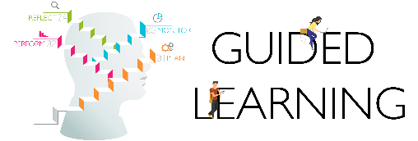
PERFORM.MONITOR

GL07A – Milestone Progress Report
for Student’s Self-Monitoring of Learning Project
(revised on 19 Feb 2020)

Student Name: | Kang Kai Feng | Admin No.: | 2202564G
Facilitator’s Name | Elsie Hui
Draft No. | 1

Learning Goals/tasks:
- I plan to compose 2 short pieces/segments, each of different periods and in the styles of the revolutionaries of each era

- I will then perform my composition to further reinforce my learning.

- Write a reflection on the influences of the revolutionaries I took inspiration from on the music of their eras from the information I gathered during my research.
  - I will write a reflection analysing one or more of my compositions against the source(s) of its inspiration to show similarities as a proof of my learning.
Right now, I have composed my two pieces of the Baroque and Classical eras and am beginning on my reflections.
Current learning status and milestones?  PLAN  Reflections (Mozart and finish up Bach)  PERFORM  Research and ideation of Mozart and Bach’s compositional styles  Research on musical periods and eras  MONITOR  Research on Mozart and Bach’s lives  REFLECT  Performance of the pieces  Finishing up the e-portfolio | Evidence of current status and milestones  PLAN  I have finished my reflection for Bach, and am left with Mozart’s reflection, the following screenshots serves as evidence of my progress on my reflections for Bach and Mozart respectively.  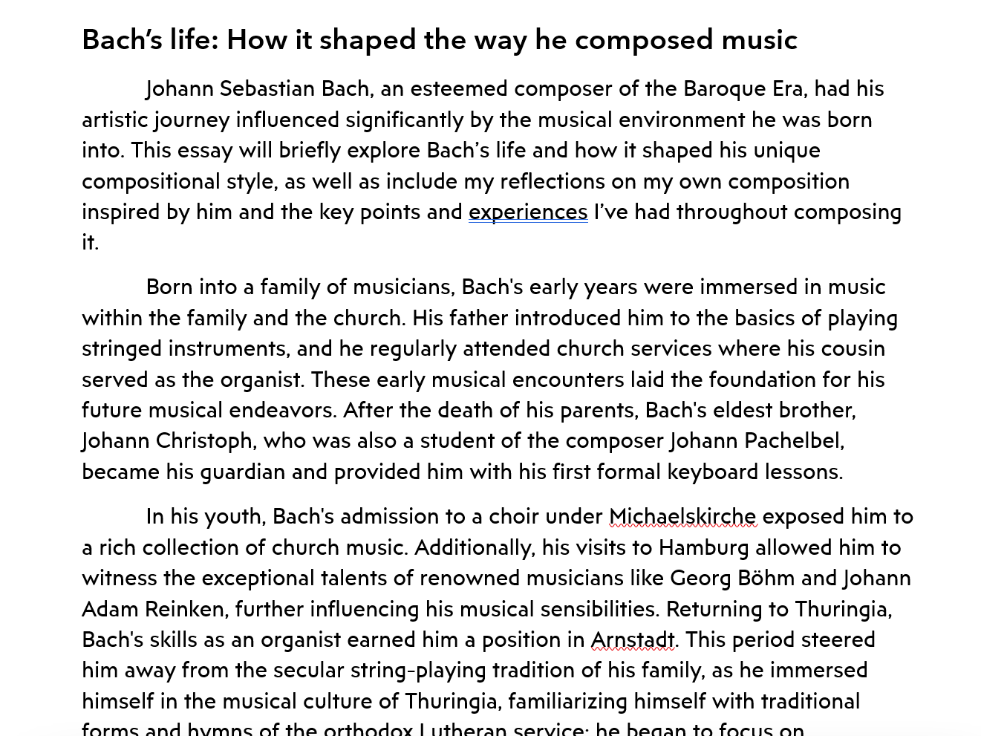  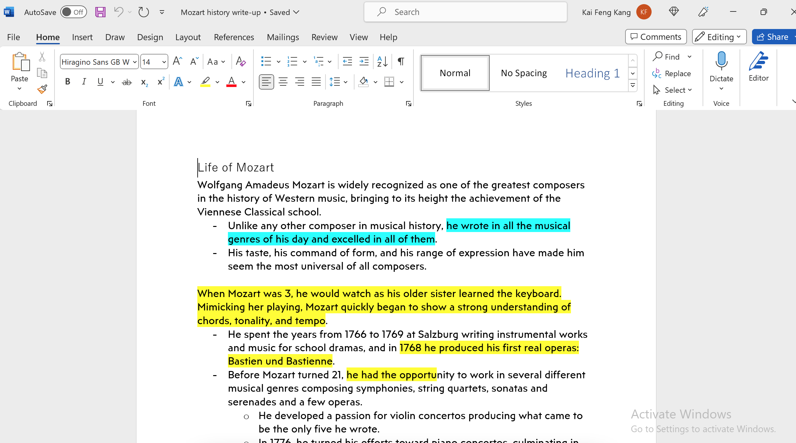  PERFORM  I have performed my research and collected all the necessary information I need to begin my reflections. I have updated my portfolio with these ideations and data collection documents. The page can be accessed through this link.  MONITOR  I have performed my research and collected all the necessary information I need to begin my reflections. I have updated my portfolio with these ideations and data collection documents. The page can be accessed through this link.  REFLECT  I have finished recording and performing my pieces, and uploaded them to my portfolio. The updated page can be accessed through this link.
Plan to meet the unfulfilled goals/tasks:  1. Set aside time to perform research and to type out the essay  2. Compare various sources detailing Bach and Mozart’s lives to ensure accuracy of information  3. Cross-refer between sources to ensure consistency of information | Evidence of achieving my goals/tasks:  PLAN  https://kaifeng.kangfamily.asia/2023/06/29/my-reflections/  PERFORM  https://kaifeng.kangfamily.asia/2023/06/29/research-and-ideation/  MONITOR  https://kaifeng.kangfamily.asia/2023/06/29/research-and-ideation/  REFLECT  https://kaifeng.kangfamily.asia/2023/05/18/my-firsst-journey/

